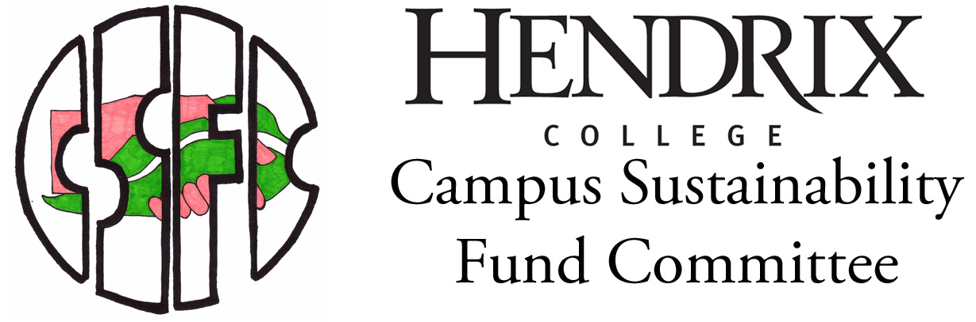
William O’Brochta, Chair and Chief Sustainability Officer
Box 3915 • (540) 525-6607 • CSFC@Hendrix.edu • Hendrix.edu/CSFC

Project Status Report

This Project Status Report form must be completed not less than once per semester. E-mail the completed form to CSFC@Hendrix.edu. This form also serves as one of the two forms to be submitted at the conclusion of the project, the other being the Project Completion Report.

Project Title:
Initial Application Date:
Today’s Date:
Primary Applicant Name:
Total Funding Amount:

Current Project Balance:
Current Percent of Project Completed:
Projected Completion Date:

- Project Performance
Quantify or estimate all fields below that are applicable.

Active Volunteers
Animals Serviced
Classes Visited
Community Groups Visited
Compost Produced
Electricity Generated
Electricity Saved
Events Attended
Events Organized
Experts Contacted
Facebook Likes
Food Grown
Gasoline Saved
Media Mentions (list all)
Peer Reviewers
Plants Installed
Recycling Rates
Rides Diverted
Service Learning Opportunities Created
Solid Waste Contamination Rates
Square Footage of Project
Stormwater Diverted
Students Affected
Students Employed
Thermal Efficiency Changes
Tours Given
Total Volunteer Hours
Thank You Notes Sent
Twitter Followers
Users
Videos Produced
Visitors
Waste Diverted
Wastewater Captured
Water Saved
Web Hits

Other Measures (list all)

- Milestones
Describe parts of the project completed during this semester.

- Challenges
Describe obstacles have you faced in working on the project this semester.

- Changes
Describe any changes that have taken place to the project or if any changes are imminent.

